Recipe management system

Name- RIthwik B

SEC- G

SRN -PES2UG21CS433

Model

The Model layer will implement the data structures representing recipes, ingredients, and potentially user information thus will consist of the business logic.

View

View layer will utilize HTML templates to display recipe lists, detailed information pages, and search results . View consists of User Interface , which provides a seamless interaction for the user with the recipe management system.

Controller

Acts as a link between the model and the view.

Coordinates interactions between model and view.

Code snippets

VIEW

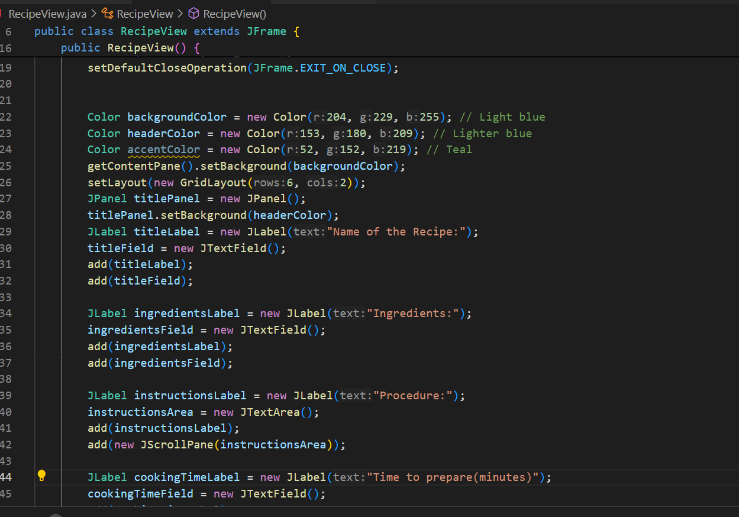

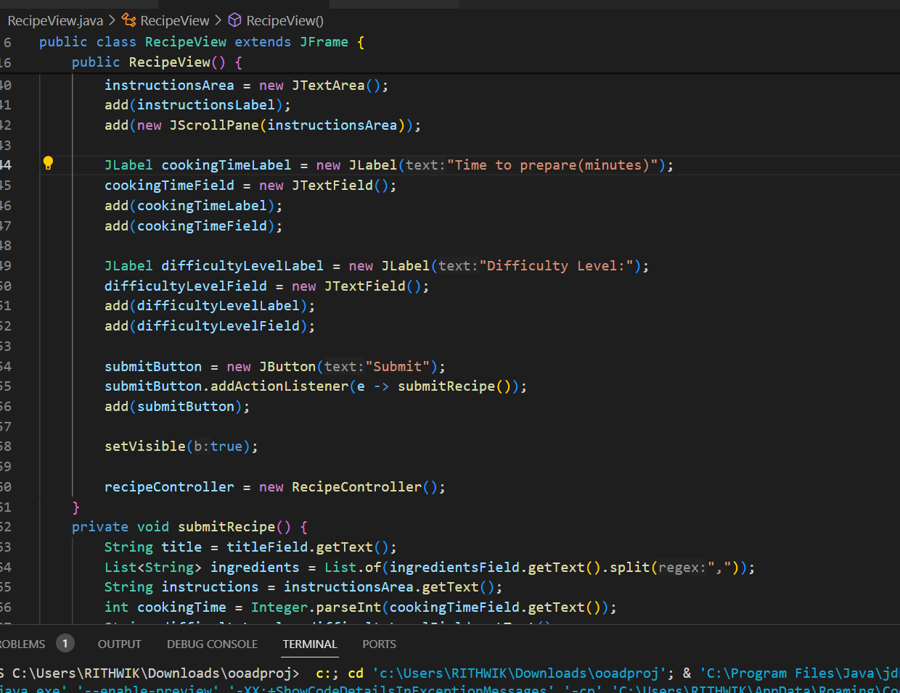

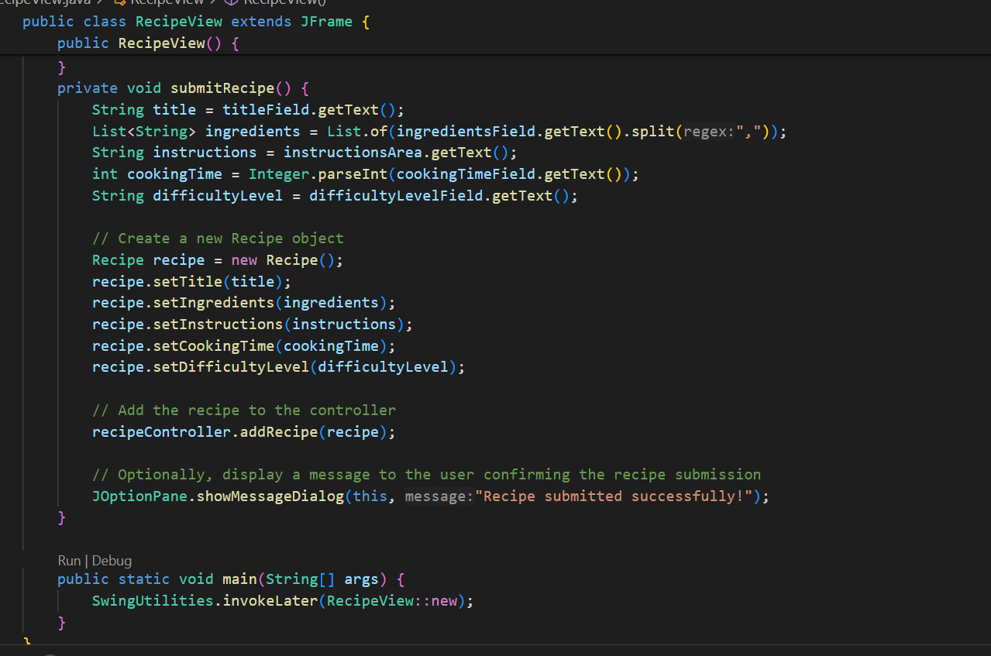

Model

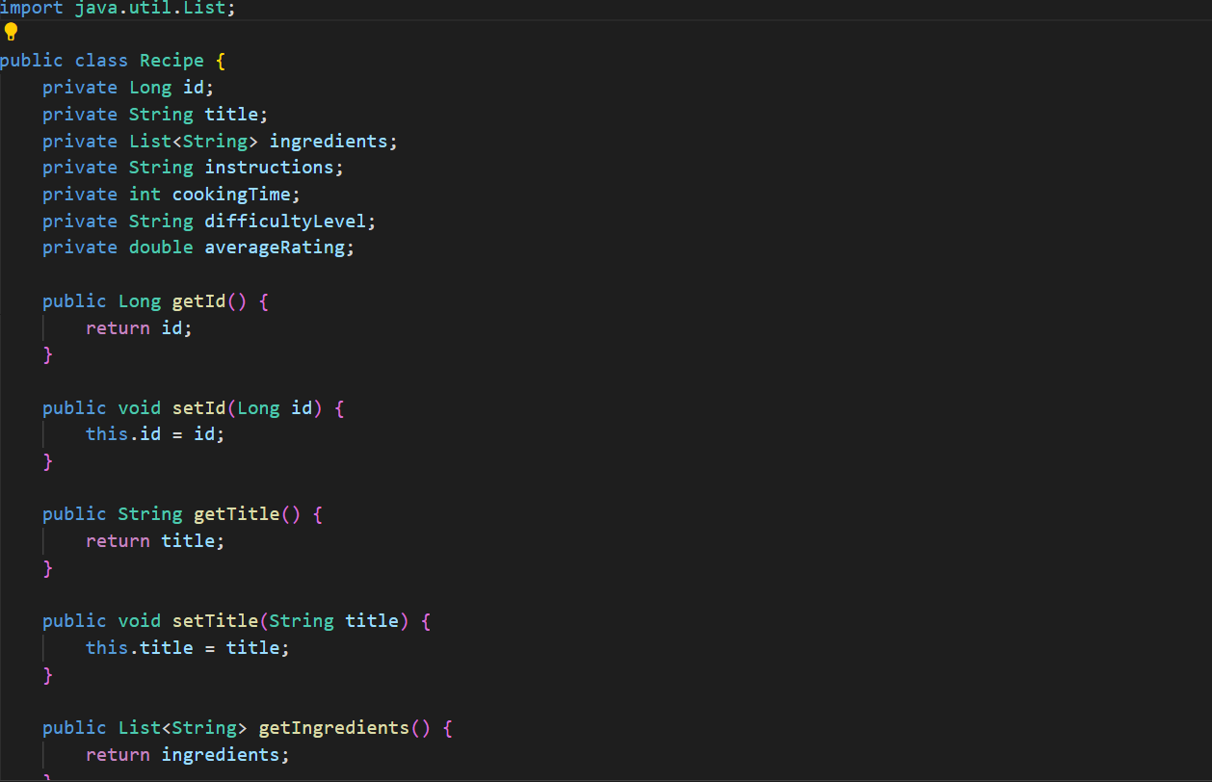

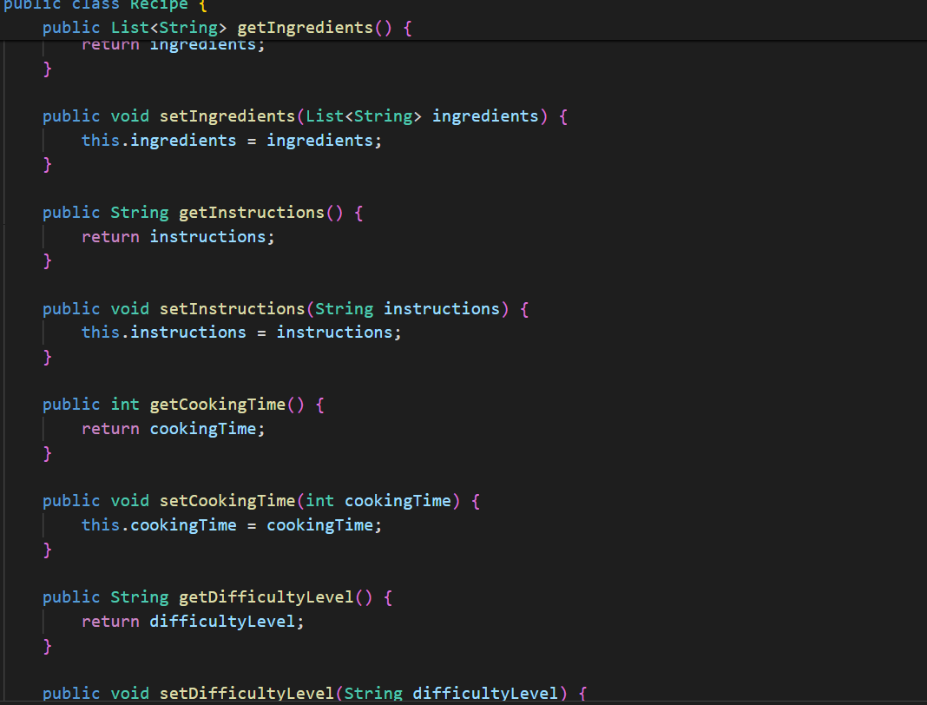

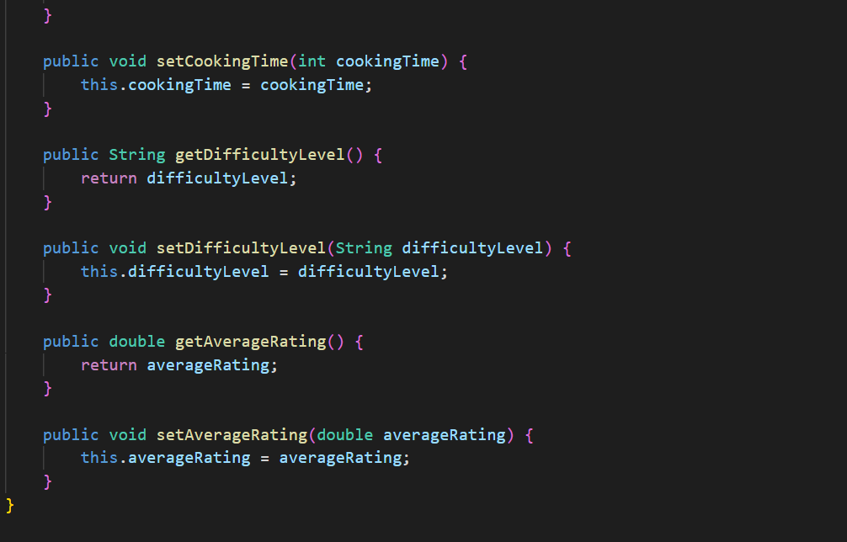

Controller

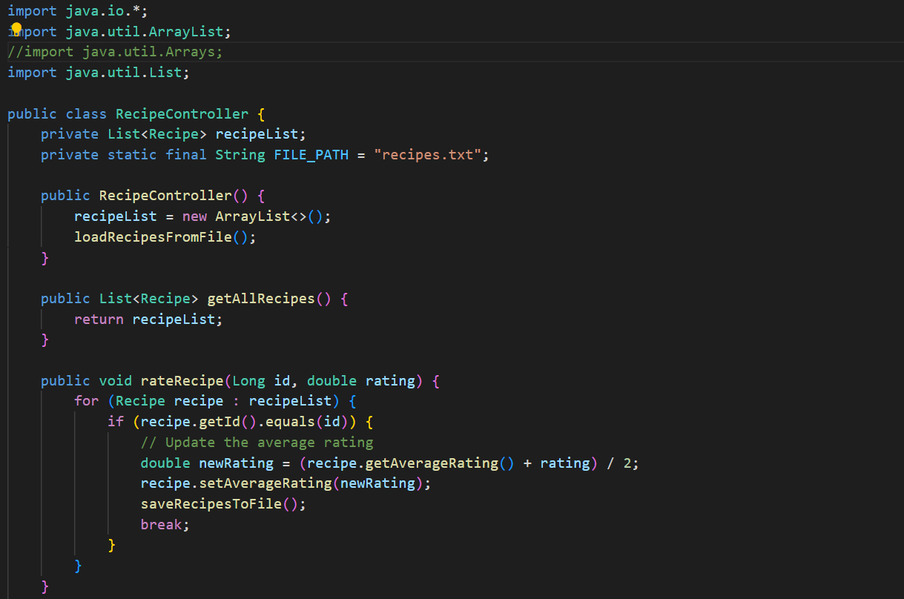

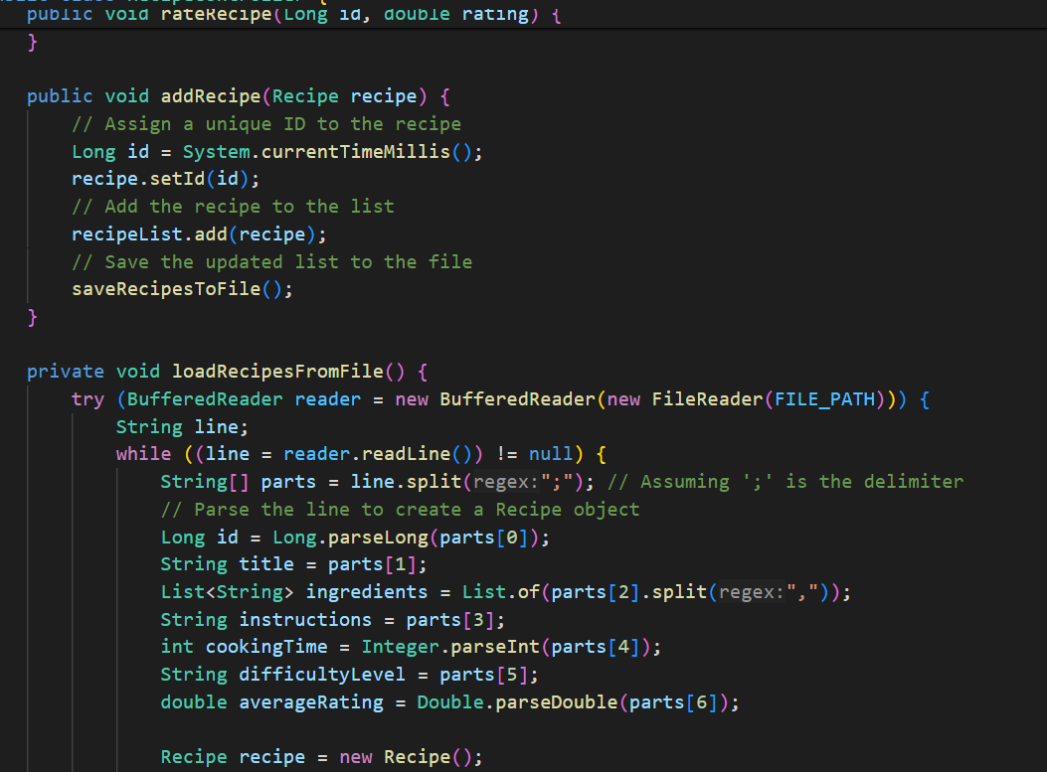

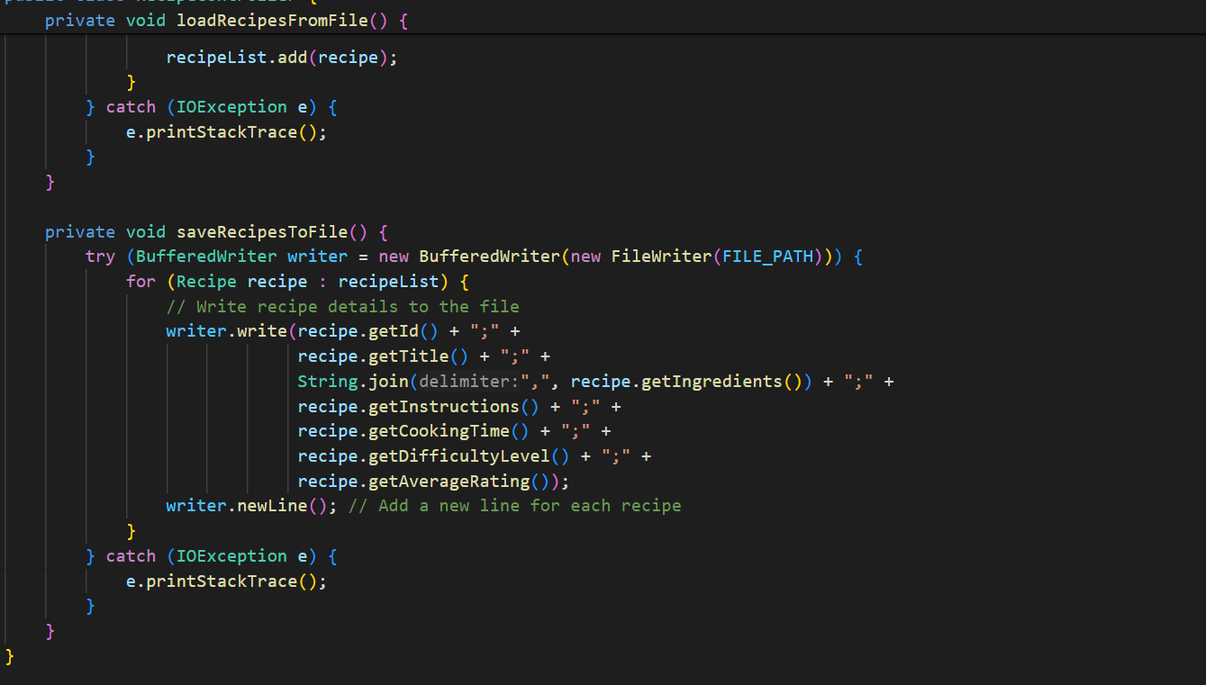

Output

